CREATE JAVA APPLICATION

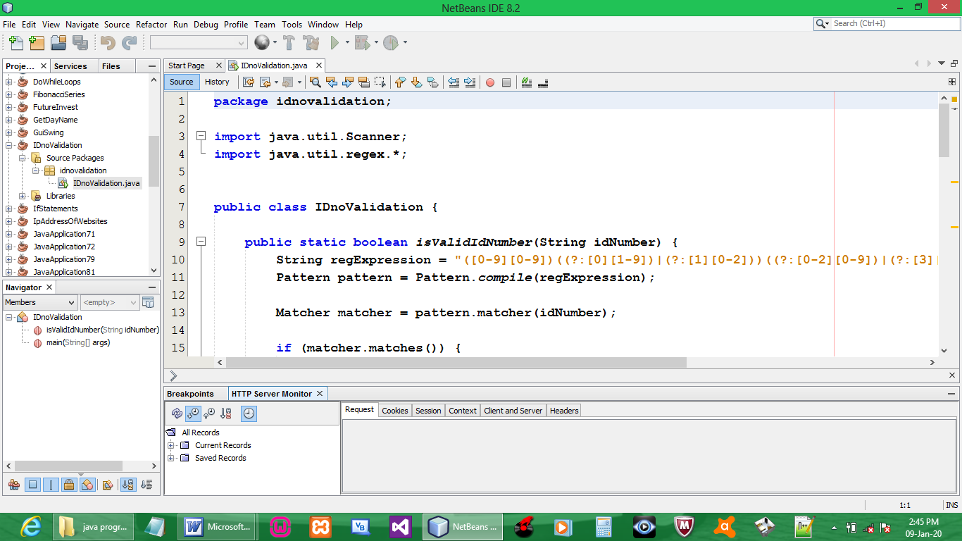

CODE:

package idnovalidation;

import java.util.Scanner;
import java.util.regex.*;

public class IDnoValidation {

public static boolean isValidIdNumber(String idNumber) {
String regExpression = "([0-9][0-9])((?:[0][1-9])|(?:[1][0-2]))((?:[0-2][0-9])|(?:[3][0-1]))([0-9])([0-9]{3})([0-9])([0-9])([0-9])";
Pattern pattern = Pattern.compile(regExpression);

Matcher matcher = pattern.matcher(idNumber);

if (matcher.matches()) {

int tot1 = 0;
for (int i = 0; i < idNumber.length() - 1; i += 2) {
tot1 = tot1 + Integer.parseInt(idNumber.substring(i, i + 1));
}

StringBuffer field1 = new StringBuffer("");
for (int i = 1; i < idNumber.length(); i += 2) {
field1.append(idNumber.substring(i, i + 1));
}

String evenTotStr = (Long.parseLong(field1.toString()) * 2) + "";
int tot2 = 0;
for (int i = 0; i < evenTotStr.length(); i++) {
tot2 = tot2 + Integer.parseInt(evenTotStr.substring(i, i + 1));
}
int lastD = (10 - ((tot1 + tot2) % 10)) % 10;
int checkD = Integer.parseInt(idNumber.substring(12, 13));

if (checkD == lastD) {
return true;
} else {
return false;
}
} else {
return false;
}
}

public static void main(String[] args) {
@SuppressWarnings("resource")
Scanner input = new Scanner(System.in);

System.out.println("Enter South African ID: ");
String id=input.nextLine();

if(isValidIdNumber(id))
{
System.out.println("Valid");
}
else
{
System.out.println("Not Valid");
}
}
}

OUTPUT:

